Assignment – 8

* **Configuration of DNS server.**
* Procedure:

Step 1 : Take 1 Switch, 3 PC’s and one server.

Step 2 : Connect that Switch with 3 PC’s with Copper Stright-Through wire and

connect the server with that switch.

Step 3 : Assign IP Addresses to the PC’s and each of them belongs to class C

or use DHCP configuration for IP assigning.

Step 4 : Assign IP Address to the server and also add the same address in DNS

Server option.

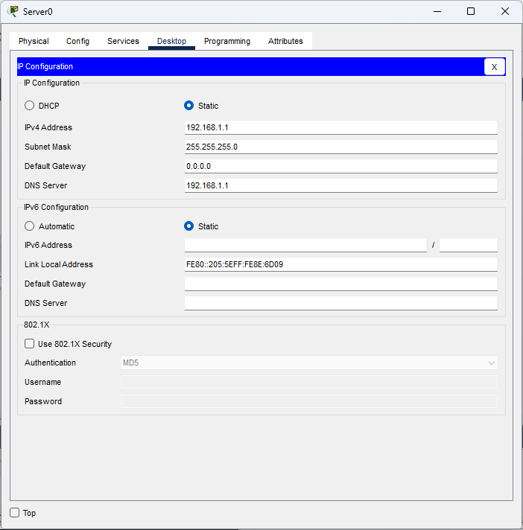

Step 4 : Now go to the services then go to DNS option and enable it.

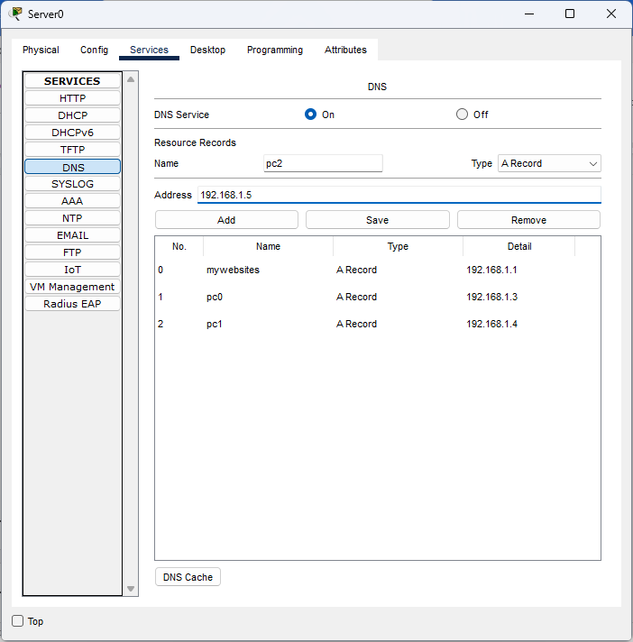

Step 6 : After that we add name and the address of the PC and click on the

add button and the domain name will be added.



* Diagram:

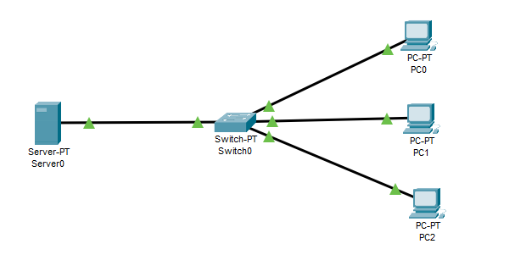

* Output’s:

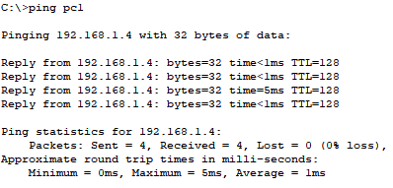

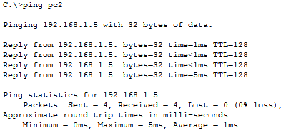

Response coming from same one PC to another PC by using domain name, so configuration is successful.